Completed Project Photos: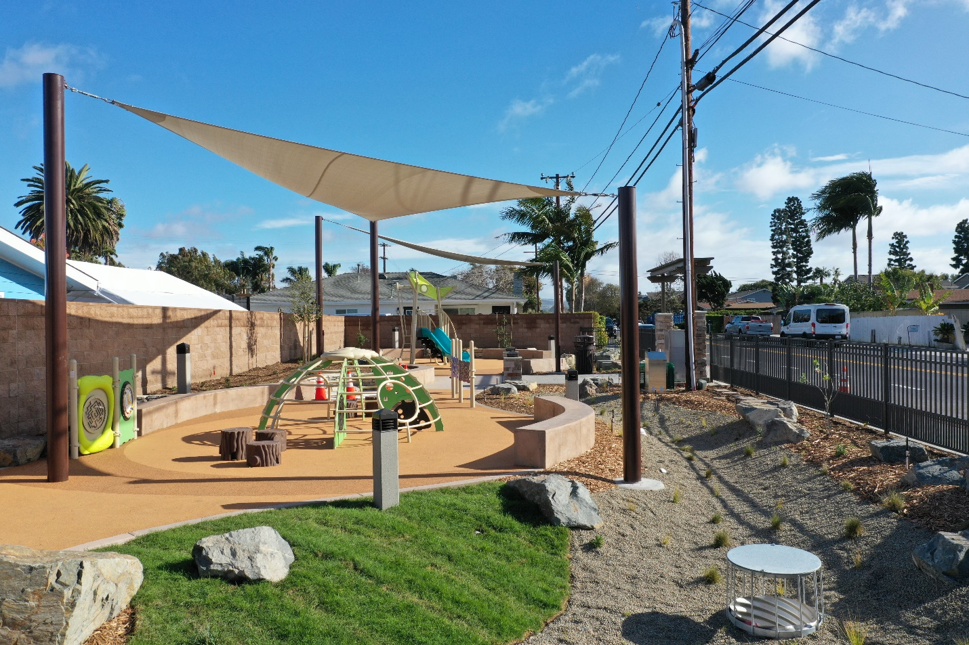
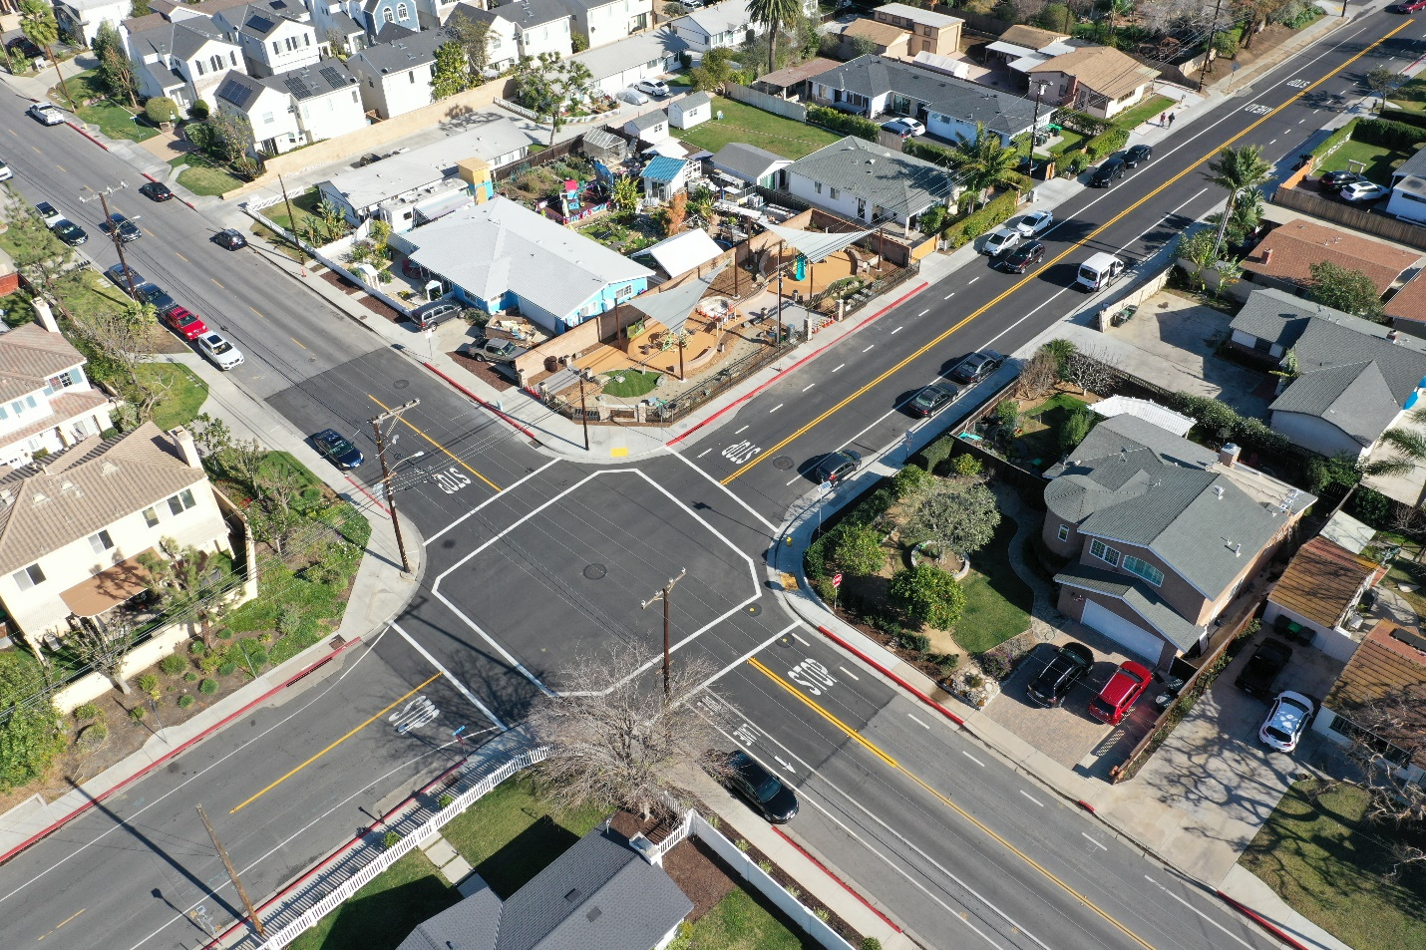
Pre-Project Photos:
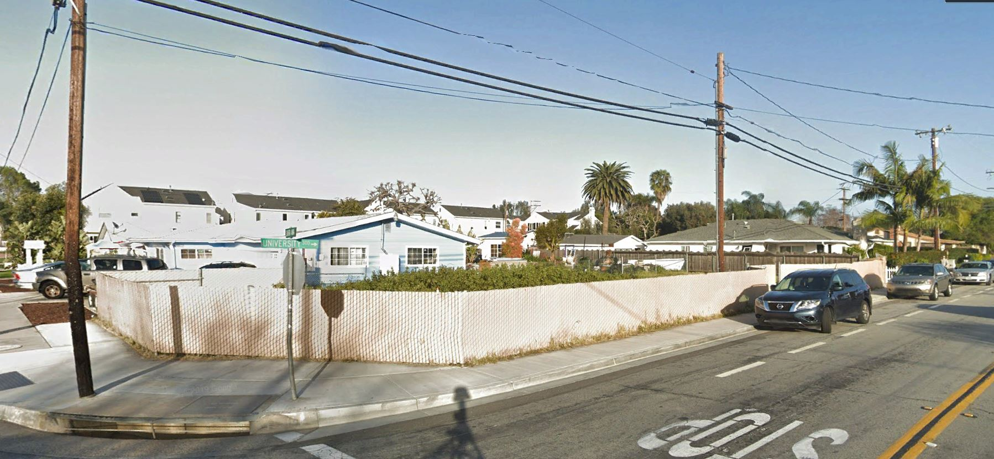
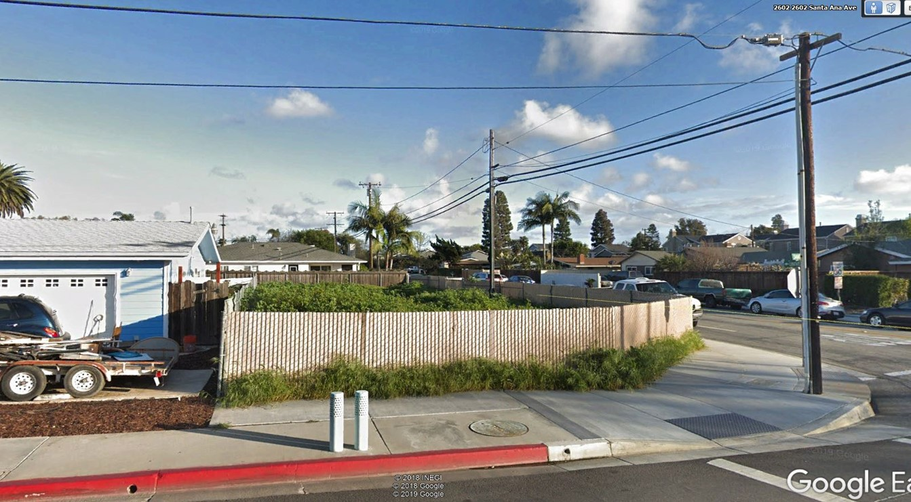

City of Costa Mesa – Virtual Park Opening Ceremony
https://www.youtube.com/watch?v=yQQvYtG1THA

LA Times – City of Costa Mesa Parks, Arts, and Community Services Commission Meeting
https://www.latimes.com/socal/daily-pilot/news/story/2019-07-26/vacant-eastside-lot-could-be-costa-mesas-next-park

LA Times – City of Costa Mesa Council Meeting
https://www.latimes.com/socal/daily-pilot/news/story/2019-09-18/costa-mesa-council-gives-thumbs-up-to-eastside-pocket-park

